# VISVESVARAYA TECHNOLOGICAL

# UNIVERSITY

**Jnana Sangama, Belagavi-590018**



## INTERNSHIP REPORT

**‘‘MUSHROOM CULTIVATION & PYTHON PROGRAMMING’’**

Undertaken at

**ENTREPRENEURSHIP/INNOVATION BASED INTERNSHIP**

Submitted in partial fulfilment of the requirement for the the award of the Degree

## BACHELOR OF ENGINEERING IN

**COMPUTER SCIENCE AND ENGINEERING**

### For the Academic Year 2023-2024

Submitted by

**GIRISHGOUDA C PATIL (3BK21CS013)**

**Under the Guidance of**

**Internal Guide External Guide**

**Prof. Suvarnalata Hiremath 1.Basavaraj K**

**2.Dr. Angela Yu (innovation)**



### DEPARTMENT OF COMPUTER SCIENCE AND ENGINEERING BASAVAKALYAN ENGINEERING COLLEGE BASAVAKAYLAN

**[Affiliated to VTU,Belgavi,Approved by AICTE,New Delhi]**

# BASAVAKALYAN ENGINEERING COLLEGE

**Affiliated to VTU,Belgavi,Approved by AICTE,New Delhi**

# DEPARTMENT OF COMPUTER SCIENCE AND ENGINEERING

**CERTIFICATE**



Certified that the INTERNSHIP REPORT on "MUSHROOM CULTIVATION" regarding the internship undertaken "FAMILY BUSINESS, BASAVAKALYAN" is prepared by at GIRISHGOUDA CHANDRAGOUDA PATIL (3BK21CS013), a bonafide student of BASAVAKALYAN ENGINEERING COLLEGE BASAVAKALYAN. The report is in partial fulfillment of the requirements for the award of the degree of Bachelor of Engineering" in Computer science and Engineering from the Visvesvaraya Technological University, Belgaum, Karnataka State, India, during the academic year 2023-2024, It is certified that all corrections/suggestions indicated for Internal Assessment have been incorporated in the report submitted to the Department. The Internship report has been approved as it satisfies the academic requirement in respect to the work prescribed for the said Degree.

**Signature of the Guide Signature of the HOD**

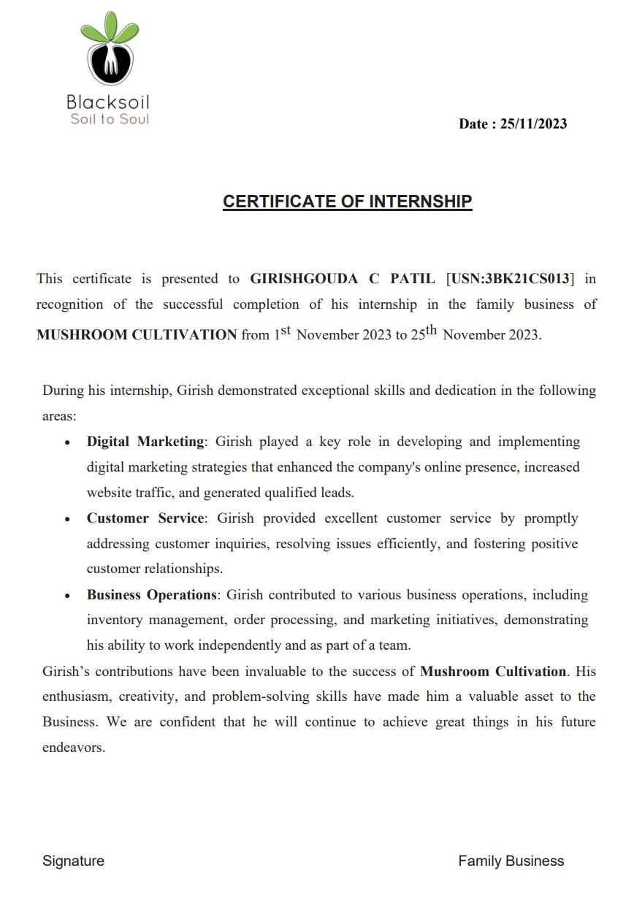



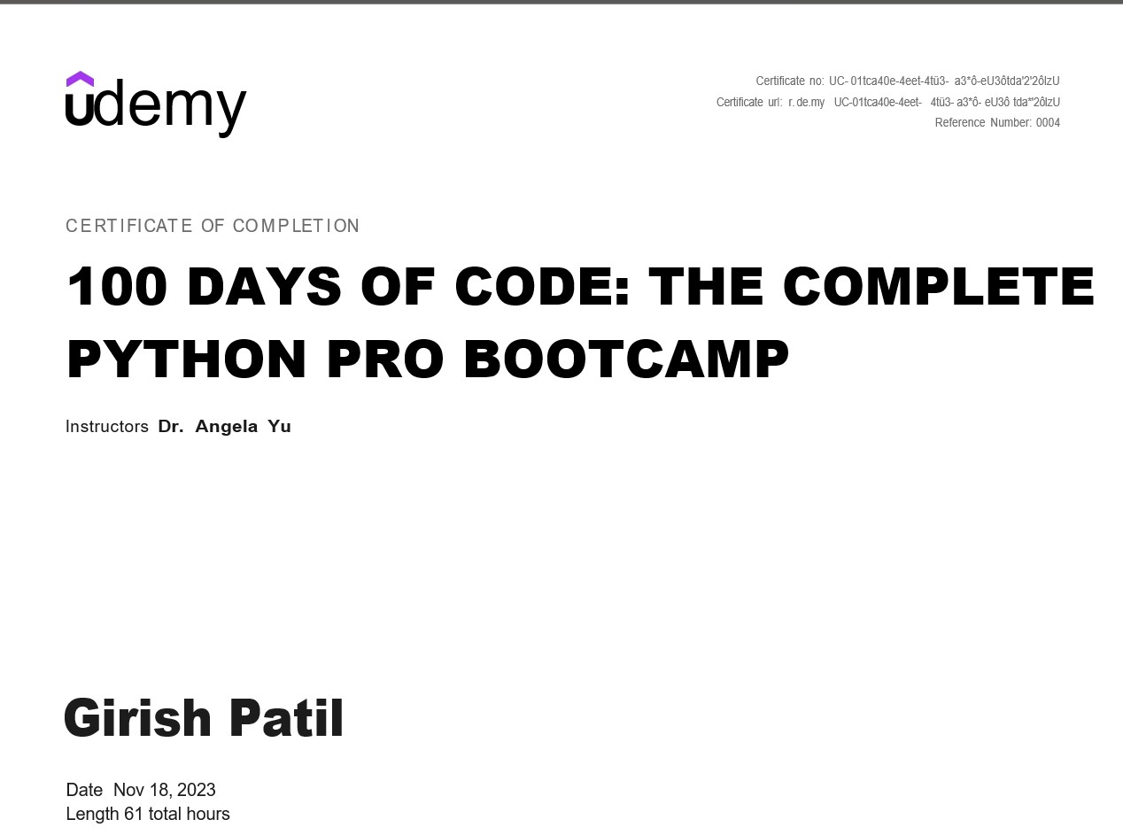

ACKNOWLEDGEMENT

I would like to express my sincere gratitude to Bas for their invaluable guidance, mentorship, and support throughout my entrepreneurial journey. Their wisdom and expertise have been instrumental in shaping my understanding of business and fostering my growth as an entrepreneur.

Additionally, I am immensely thankful to Dr. Angelica Yu for providing me with comprehensive knowledge and practical skills in Python Pro bootcamp. The course has equipped me with the tools and insights necessary to excel in my chosen field and has greatly contributed to my professional development.

I am also grateful to Head of Department Suvarnalata Hiremath, College internship coordinator Department of CSE for their assistance and encouragement along the way.

Thank you all for your unwavering support and belief in my potential.

Sincerely,

Girishgouda Chandragouda Patil

**ABSTRACT**

This internship report delves into the transformative experiences gained from engaging with both an esteemed entrepreneur and an online course. The entrepreneur, Basavaraj G K, served as a guiding light, imparting invaluable wisdom and insights into the intricacies of entrepreneurship. Through their mentorship, I navigated the complexities of business with newfound confidence and determination.

Simultaneously, the online course, Dr. Angelica Yu Udemy, proved to be a cornerstone in my professional development. Delving into Python Pro bootcamp, it equipped me with practical skills and theoretical knowledge essential for success in today's competitive landscape.

This abstract encapsulates the synergy between practical mentorship from a seasoned entrepreneur and structured learning from an online course, offering a holistic approach to honing entrepreneurial skills and fostering personal growth.

TABLE OF CONTENTS

|  |  |  |  |
| --- | --- | --- | --- |
| **Sl. No** | **Chapter** | **Topic** | **Page no.** |
| 1. | Chapter 1 | Introduction | 5-6 |
| 2. | Chapter 2 | Knowledge Acquired for  Entrepreneurship | 7-12 |
| 3. | Chapter 3 | Outcome of Entrepreneurship | 12-13 |
| 4. | Chapter 4 | Implementation of Entrepreneurship | 14-18 |
| 5. | Chapter 5 | Knowledge Acquired for  Python programming | 19-20 |
| 6. | Chapter 6 | Outcome of Python programming | 21-22 |
| 7. | Chapter 7 | Conclusion | 23-24 |
| 8. | References | | 25 |

**CHAPTER 1**

**INTRODUCTION TO ENTREPRENEURSHIP**

An internship in a family business can be a unique and enriching experience, blending professional development with personal insights into how businesses are run within the familial context.

1. **Understanding the Family Dynamics:** In a family business, dynamics can be complex. There may be multiple generations involved, each with their own ideas and priorities. Understanding these dynamics is crucial for navigating relationships and decision-making processes.

2. **Learning the Business:** Start by familiarizing yourself with the company's history, values, products or services, and target market. This knowledge forms the foundation for your internship experience and helps you contribute meaningfully to the business.

3. **Identifying Your Role**: Clarify your role and responsibilities with your supervisor or mentor. You might be involved in various areas such as operations, marketing, finance, or human resources. Understanding where you fit in allows you to set goals and expectations for your internship.

4. **Building Relationships:** Networking is key in any internship, but it's especially important in a family business where personal connections play a significant role. Take the time to get to know your colleagues, both family members and non-family employees, as they can offer valuable insights and support.

5. **Gaining Hands-on Experience:** One of the major benefits of an internship is gaining practical experience. Take advantage of opportunities to shadow experienced employees, work on projects, and contribute your ideas. This hands-on experience will help you develop skills and knowledge relevant to your career goals.

6. **Navigating Challenges:** Working in a family business may present unique challenges, such as balancing family dynamics with professional responsibilities or addressing conflicts of interest. Be prepared to adapt and communicate effectively to overcome these challenges.

7. **Seeking Feedback and Growth:** Actively seek feedback from your supervisors and colleagues to identify areas for improvement and opportunities for growth. Use this feedback to refine your skills and enhance your performance throughout the internship.

8. **Reflecting on Your Experience:** Take time to reflect on your internship experience, considering what you've learned, the skills you've developed, and how it aligns with your career aspirations. This reflection will help you derive maximum value from your internship and prepare for future endeavors.

Remember, an internship in a family business can be a rewarding and educational experience, offering insights into both business operations and family dynamics. Approach it with an open mind, a willingness to learn, and a commitment to professionalism.

.

**CHAPTER 2**

**KNOWLEDGE ACQUIRED FOR ENTREPRENEURSHIP**

**Introduction:**

Embarking on the journey of establishing a mushroom cultivation business entails navigating the intricate realms of agricultural entrepreneurship. Aspiring to cultivate mushrooms not only signifies a commitment to sustainable food production but also underscores a recognition of the burgeoning demand for nutritious and versatile fungi. This introductory phase involves delving into the multifaceted landscape of mushroom cultivation, encompassing aspects such as species selection, cultivation methods, market analysis, and regulatory considerations. With a vision of contributing to the burgeoning fungi industry, the stage is set for a transformative exploration into the realm of mushroom cultivation entrepreneurship.

**Species Selection and Cultivation Methods:**

Central to the success of a mushroom cultivation business is the strategic selection of mushroom species and cultivation methods. This phase involves meticulous research into the characteristics, growing requirements, and market demand for various mushroom species, such as oyster mushrooms, shiitake mushrooms, and button mushrooms. Moreover, it entails a comprehensive understanding of the diverse cultivation methods available, including traditional methods like indoor cultivation on substrate bags or logs, as well as innovative techniques such as hydroponic or vertical farming. By leveraging insights gleaned from scientific research and industry best practices, entrepreneurs can make informed decisions regarding species selection and cultivation methods that align with their business objectives and target market.

**Market Analysis and Consumer Trends:**

An integral component of establishing a successful mushroom cultivation business is conducting a thorough market analysis to identify trends, opportunities, and competitive dynamics within the fungi industry. This entails evaluating factors such as consumer preferences, market segmentation, distribution channels, and pricing strategies. Furthermore, it involves staying abreast of emerging trends and innovations in the mushroom market, such as the growing demand for organic and specialty mushrooms, functional mushroom products, and mushroom-based alternatives to conventional meat and dairy products. By conducting market research and trend analysis, entrepreneurs can position their mushroom cultivation business to capitalize on evolving consumer preferences and market dynamics.

**Operational Infrastructure and Resource Management:**

Establishing a robust operational infrastructure and implementing effective resource management practices are essential for the successful operation of a mushroom cultivation business. This phase involves designing and setting up cultivation facilities, including temperature-controlled growing rooms, substrate preparation areas, and packaging facilities. Additionally, it entails optimizing resource utilization, including raw materials, water, energy, and labor, to maximize efficiency and minimize costs. Moreover, it involves implementing quality control measures and food safety protocols to ensure compliance with regulatory standards and consumer expectations. By investing in infrastructure development and resource management, entrepreneurs can create a solid foundation for sustainable growth and profitability in the mushroom cultivation industry.

**Marketing and Distribution Strategies:**

Developing effective marketing and distribution strategies is paramount for promoting products and reaching target customers in the mushroom cultivation business. This phase involves crafting compelling branding and messaging that resonates with consumers, as well as leveraging digital marketing channels, such as social media, e-commerce platforms, and content marketing, to reach a wider audience. Furthermore, it entails establishing partnerships with local retailers, restaurants, and farmers' markets to expand distribution channels and increase market penetration. Additionally, it involves exploring opportunities for value-added products, such as dried mushrooms, mushroom powders, and mushroom-based supplements, to diversify revenue streams and cater to niche markets.

**Regulatory Compliance and Sustainability Practices:**

Navigating regulatory compliance requirements and embracing sustainability practices are integral components of operating a responsible and ethical mushroom cultivation business. This phase involves obtaining necessary permits, licenses, and certifications from regulatory authorities, such as the Food and Drug Administration (FDA) and the United States Department of Agriculture (USDA), to ensure compliance with food safety and labeling standards. Furthermore, it entails implementing sustainable farming practices, such as composting, water conservation, and waste reduction, to minimize environmental impact and promote ecological stewardship. Additionally, it involves fostering transparency and accountability in supply chain management, including traceability and ethical sourcing practices, to build trust and credibility with consumers. By prioritizing regulatory compliance and sustainability practices, entrepreneurs can demonstrate their commitment to quality, safety, and environmental responsibility, thereby enhancing the long-term viability and reputation of their mushroom cultivation business.

In conclusion, the journey of establishing a mushroom cultivation business is characterized by a multifaceted exploration into the realms of agricultural entrepreneurship, market analysis, operational infrastructure, marketing strategies, regulatory compliance, and sustainability practices. By leveraging insights gleaned from scientific research, industry best practices, and market analysis, entrepreneurs can position their mushroom cultivation business for success in a dynamic and rapidly evolving industry landscape. With a commitment to innovation, quality, and sustainability, entrepreneurs can cultivate a thriving mushroom business that contributes to the growth and diversification of the fungi industry while meeting the evolving needs and preferences of consumers.

**Implementation of Digitalization:**

**1. Digital Farm Management System:** Implement a digital farm management system that centralizes all aspects of mushroom cultivation operations, including inventory management, scheduling, and task assignments. This system can provide real-time updates on crop growth, environmental conditions, and production metrics, enabling farmers to make data-driven decisions and optimize resource allocation.

**2. Automated Environmental Control Systems:** Install automated environmental control systems in cultivation facilities to monitor and regulate temperature, humidity, and ventilation levels. These systems can be programmed to maintain optimal growing conditions for different mushroom species, reducing manual labor and ensuring consistent crop yields.

**3. Smart Monitoring Sensors:** Deploy smart monitoring sensors throughout cultivation facilities to track key environmental parameters such as CO2 levels, light intensity, and substrate moisture content. These sensors can transmit data wirelessly to a centralized dashboard, allowing farmers to remotely monitor conditions and intervene proactively to prevent crop losses or optimize growth.

**4. Predictive Analytics for Yield Optimization**: Utilize predictive analytics algorithms to analyze historical data and predict future crop yields based on environmental conditions, cultivation practices, and other variables. This insight can help farmers optimize production schedules, plan harvests more effectively, and minimize waste.

**5. Digital Supply Chain Management:** Implement a digital supply chain management system to track the movement of raw materials, inputs, and finished products throughout the supply chain. This system can streamline procurement, logistics, and inventory management processes, reducing lead times and improving overall efficiency.

**6. E-commerce Platform for Sales:** Develop an e-commerce platform to sell fresh mushrooms, mushroom products, and growing supplies directly to consumers. This platform can feature an online storefront, secure payment processing, and personalized recommendations based on customer preferences, enhancing the shopping experience and expanding market reach.

**7. Customer Relationship Management (CRM) Software:** Adopt CRM software to manage customer relationships, track sales leads, and automate marketing campaigns. This software can capture customer data, analyze purchasing behavior, and personalize communications to build loyalty and drive repeat business.

By embracing digitalization across all aspects of the mushroom cultivation business, entrepreneurs can unlock new opportunities for innovation, efficiency, and sustainability, positioning their businesses for long-term success in a rapidly evolving industry landscape.

As an intern in a mushroom cultivation business, you can suggest additional contributions to boost the business in various ways:

**1.** **Research and Development Initiatives:** Conduct research on innovative cultivation techniques, new mushroom species, and value-added mushroom products. Propose experimental trials and pilot projects to test these ideas and assess their feasibility for commercialization.

**2. Quality Assurance and Standardization:** Develop quality assurance protocols and standard operating procedures (SOPs) to ensure consistent product quality and safety. Implement quality control measures such as regular inspections, microbial testing, and product sampling to maintain high standards and compliance with regulatory requirements.

**3. Market Expansion Strategies**: Identify new market opportunities and distribution channels for mushroom products, such as specialty grocery stores, farmers' markets, and online platforms. Explore partnerships with restaurants, caterers, and food service providers to increase product visibility and reach a broader customer base.

**4. Brand Building and Marketing Campaigns:** Develop branding strategies and marketing campaigns to differentiate the business from competitors and build brand awareness. Create engaging content, including videos, blog posts, and social media posts, to showcase the company's story, values, and products to target audiences.

**5. Community Engagement and Education**: Engage with the local community through educational initiatives, workshops, and events to raise awareness about the health benefits of mushrooms and sustainable farming practices. Collaborate with schools, community organizations, and health professionals to promote mushroom consumption and advocate for environmental stewardship.

**6. Sustainability and Environmental Initiatives:** Propose sustainability initiatives such as composting, water recycling, and renewable energy utilization to minimize the environmental footprint of mushroom cultivation operations. Implement eco-friendly packaging solutions and waste reduction strategies to promote environmental responsibility and reduce costs.

**7. Customer Feedback and Product Innovation:** Collect customer feedback through surveys, focus groups, and social media interactions to gather insights into preferences, tastes, and product preferences. Use this feedback to drive product innovation and develop new mushroom-based products or packaging formats that align with customer needs and preferences.

**8. Employee Training and Development:** Organize training sessions and workshops for employees to enhance their skills, knowledge, and expertise in mushroom cultivation, food safety, and customer service. Foster a culture of continuous learning and improvement to empower employees to contribute to the company's success and growth.

**9. Partnerships and Collaborations:** Explore partnerships and collaborations with research institutions, universities, and industry associations to leverage expertise, resources, and funding opportunities. Participate in collaborative research projects, technology transfer programs, and industry networks to stay at the forefront of innovation and market trends.

**CHAPTER 3**



**OUTCOME FOR ENTREPRENEURSHIP**

After implementing digitalization initiatives within the mushroom cultivation business, several notable outcomes were observed:



**Streamlined Operations and Increased Efficiency:**

Digitalization led to streamlined operations across various aspects of the business, including inventory management, scheduling, and data analysis. Automation of repetitive tasks and real-time monitoring of environmental conditions reduced manual labor and minimized human error, resulting in increased operational efficiency. As a result, tasks that once required significant time and resources could now be completed more quickly and accurately, allowing employees to focus on higher-value activities such as crop management and customer service.

**Improved Product Quality and Consistency:**

Digitalization initiatives contributed to improved product quality and consistency through better monitoring and control of cultivation conditions. Automated environmental control systems ensured optimal growing conditions for mushrooms, resulting in higher yields and better-quality crops. Additionally, quality assurance protocols and traceability systems enabled the business to track and maintain the integrity of products throughout the supply chain, ensuring compliance with regulatory standards and meeting customer expectations for safety and quality.

**Cost Savings and Resource Optimization:**

Digitalization resulted in cost savings and resource optimization by reducing waste, improving resource utilization, and minimizing operational inefficiencies. The automation of manual processes, such as inventory management and order processing, reduced labor costs and eliminated errors associated with manual data entry. Additionally, optimization of resource usage, such as water, energy, and raw materials, led to reduced overhead costs and improved profitability. Overall, digitalization initiatives enabled the business to operate more efficiently and sustainably, achieving a competitive advantage in the market while maximizing profitability and long-term viability.

**CHAPTER 4**



**IMPLEMENTATION OF DIGITILAZATION AND SOME MUSHROOM CULTIVATION SNAPSHOTS**

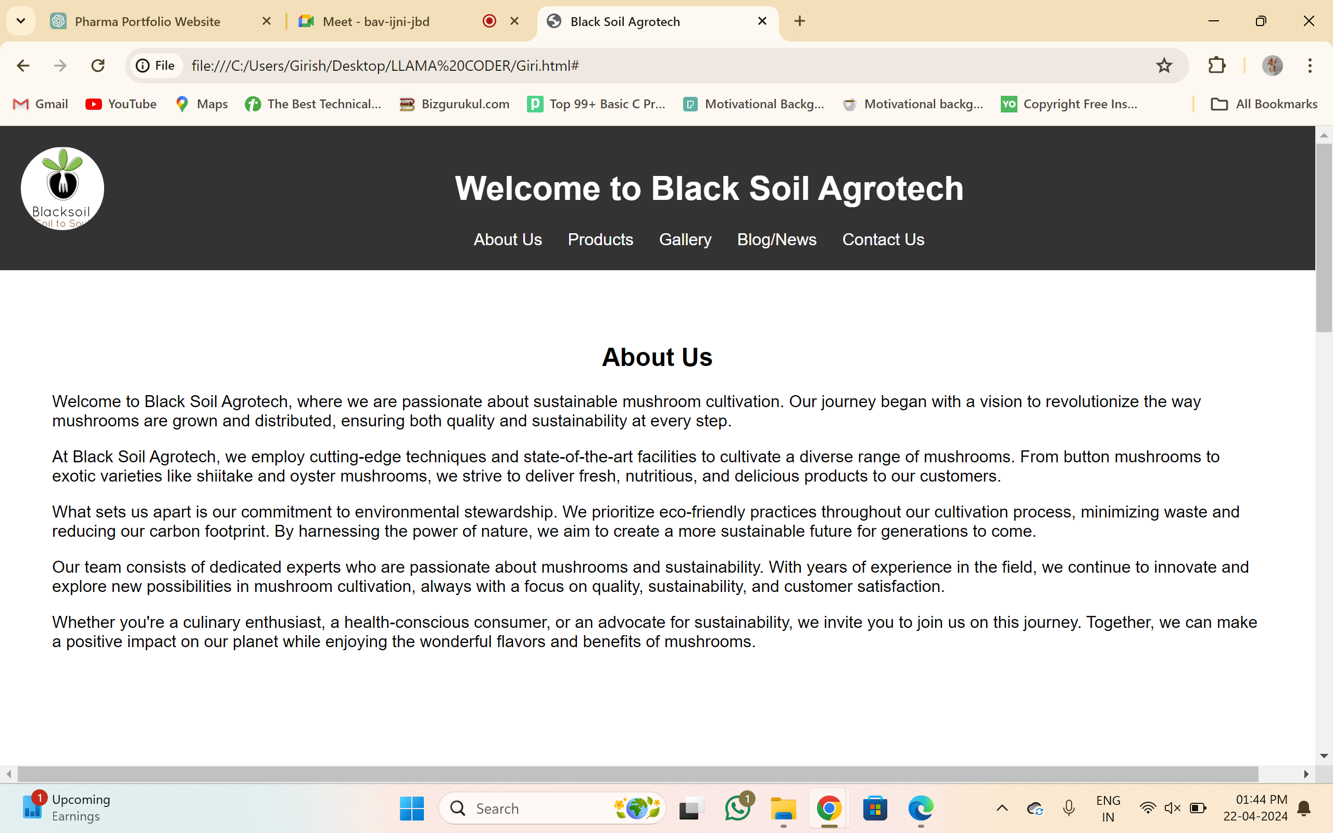

**PORTFOLIO WEBSITE**

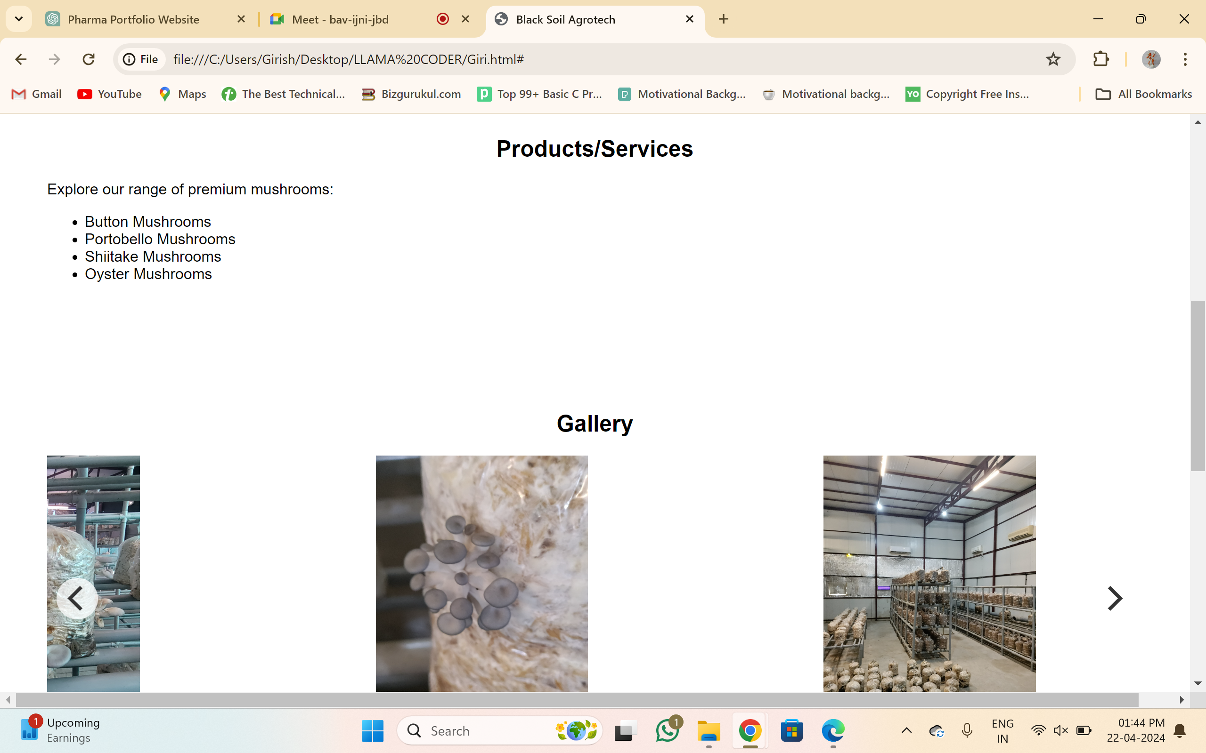



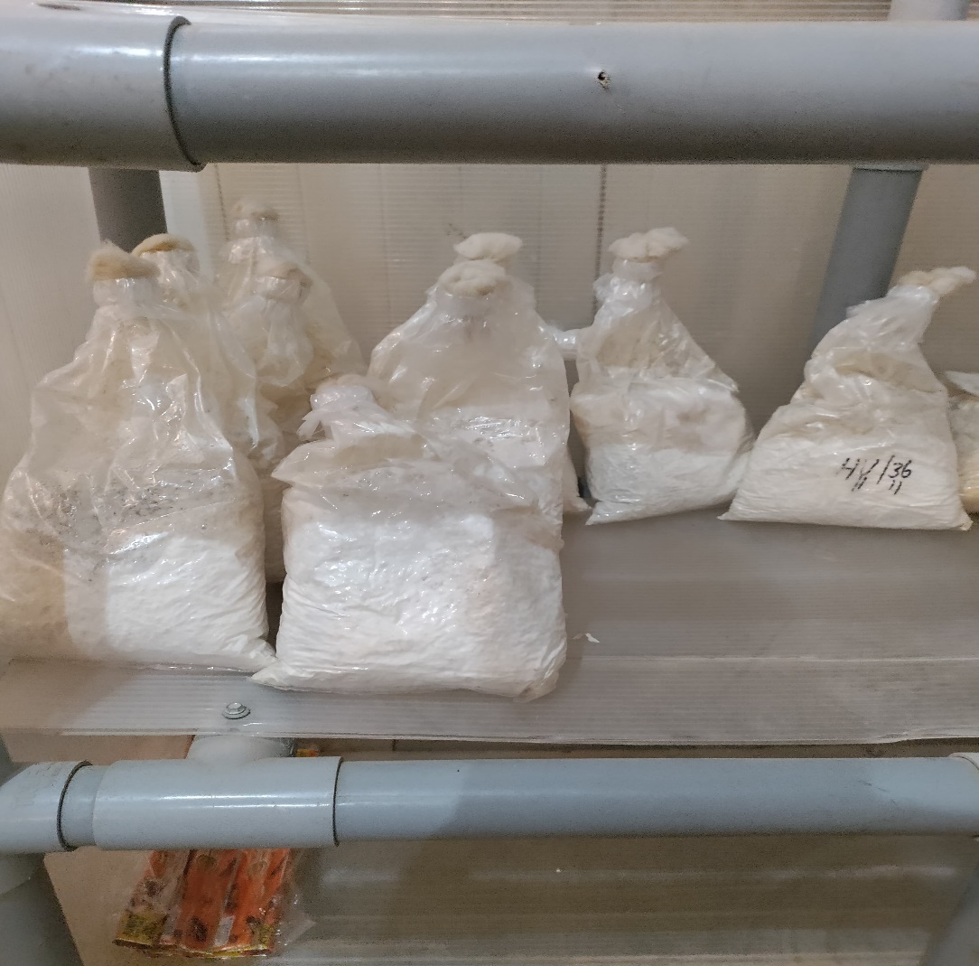

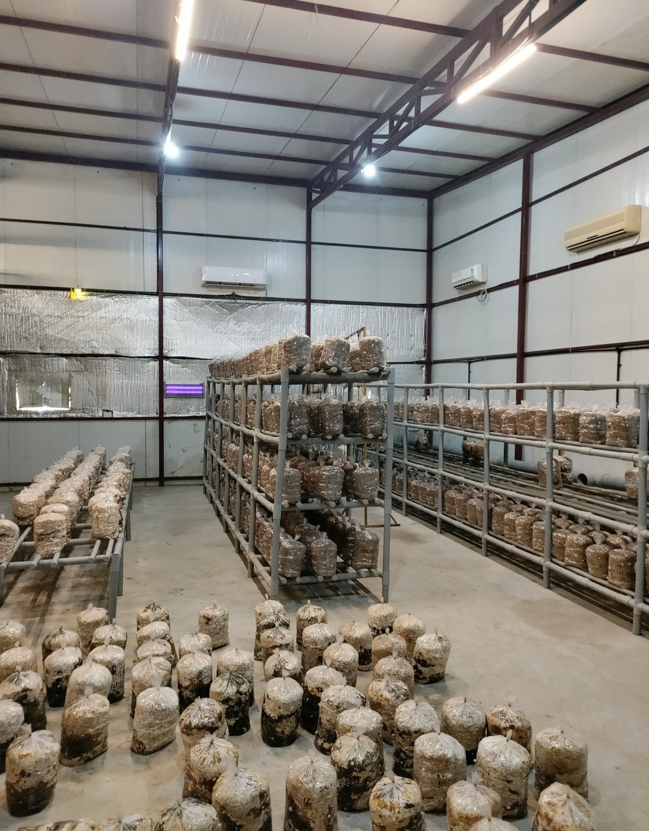

**AC MONITORED NEWLY BAG STORAGE**

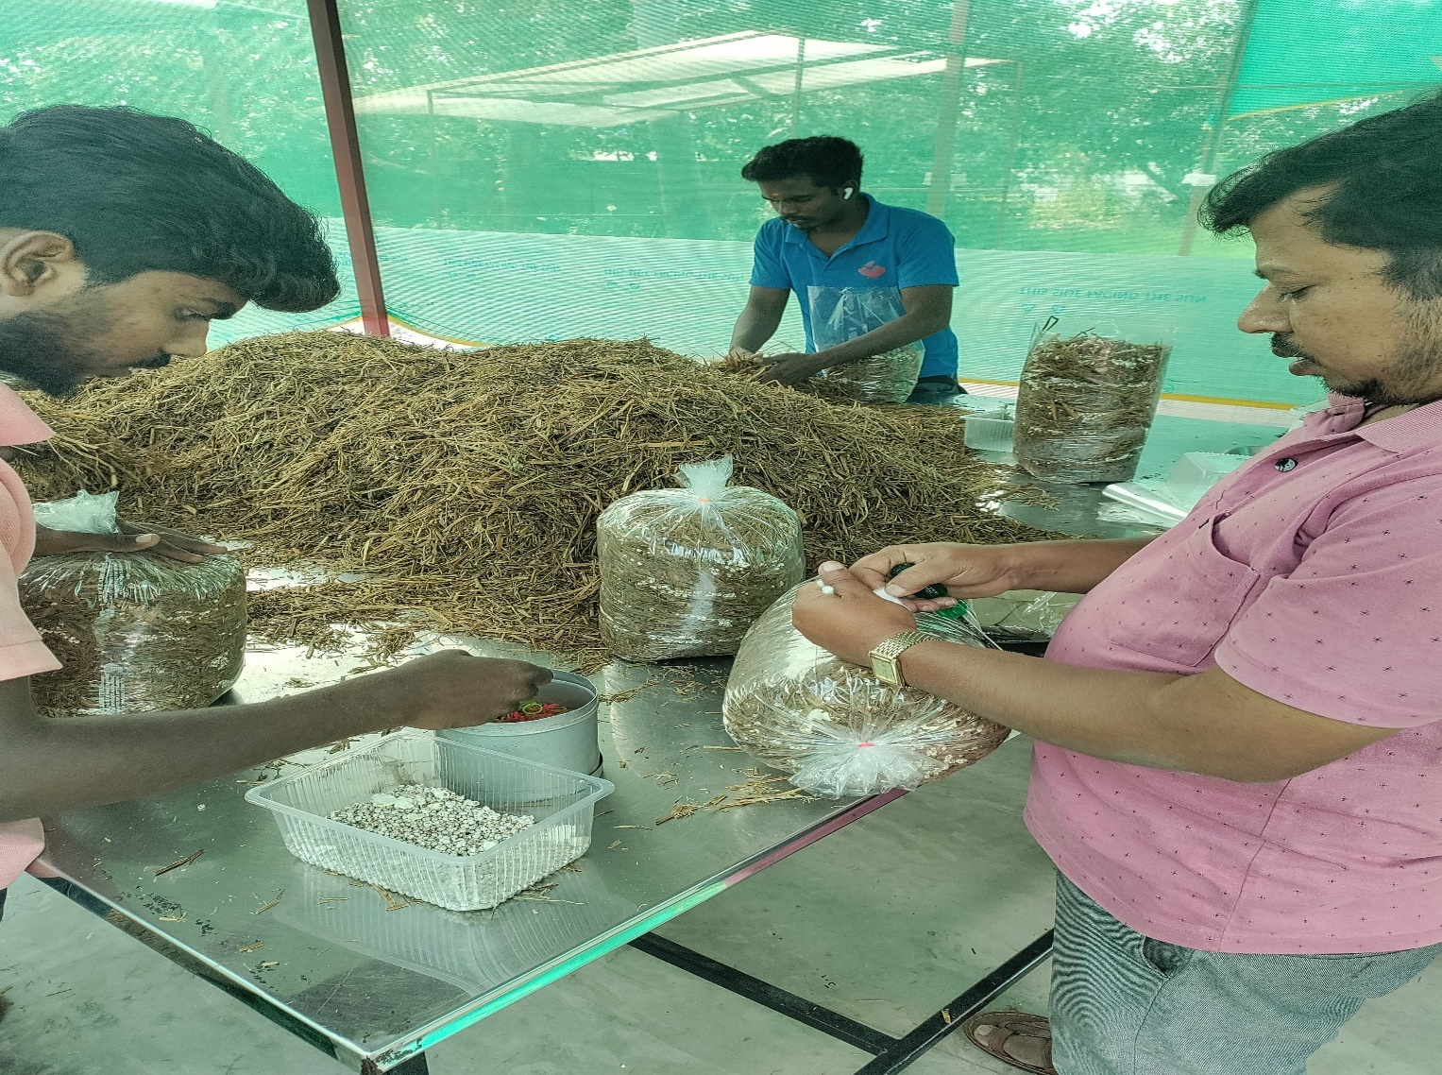

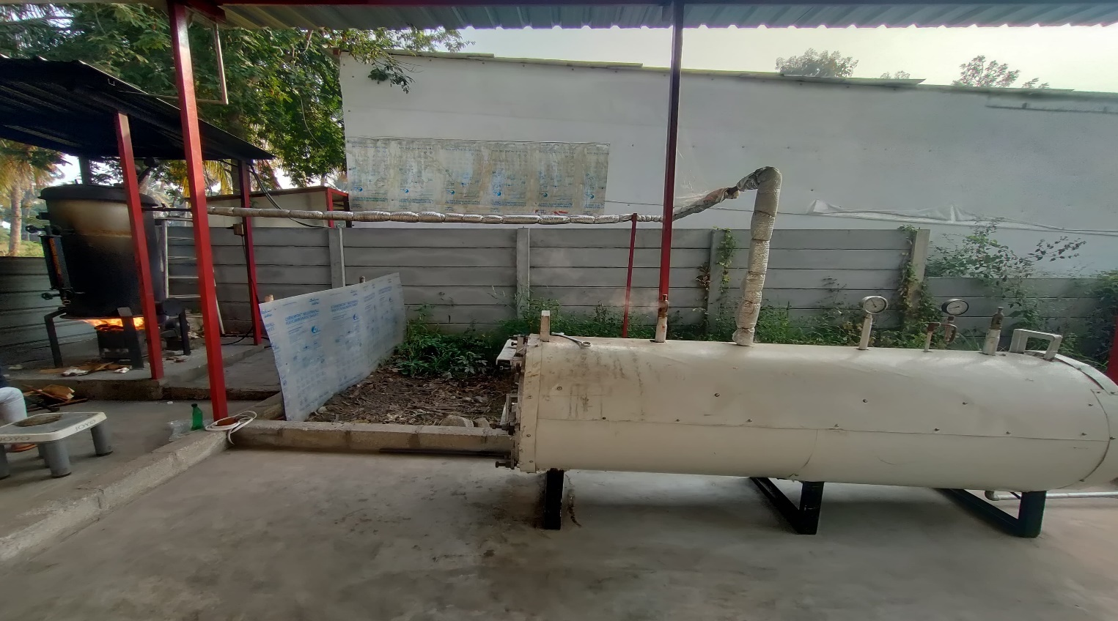

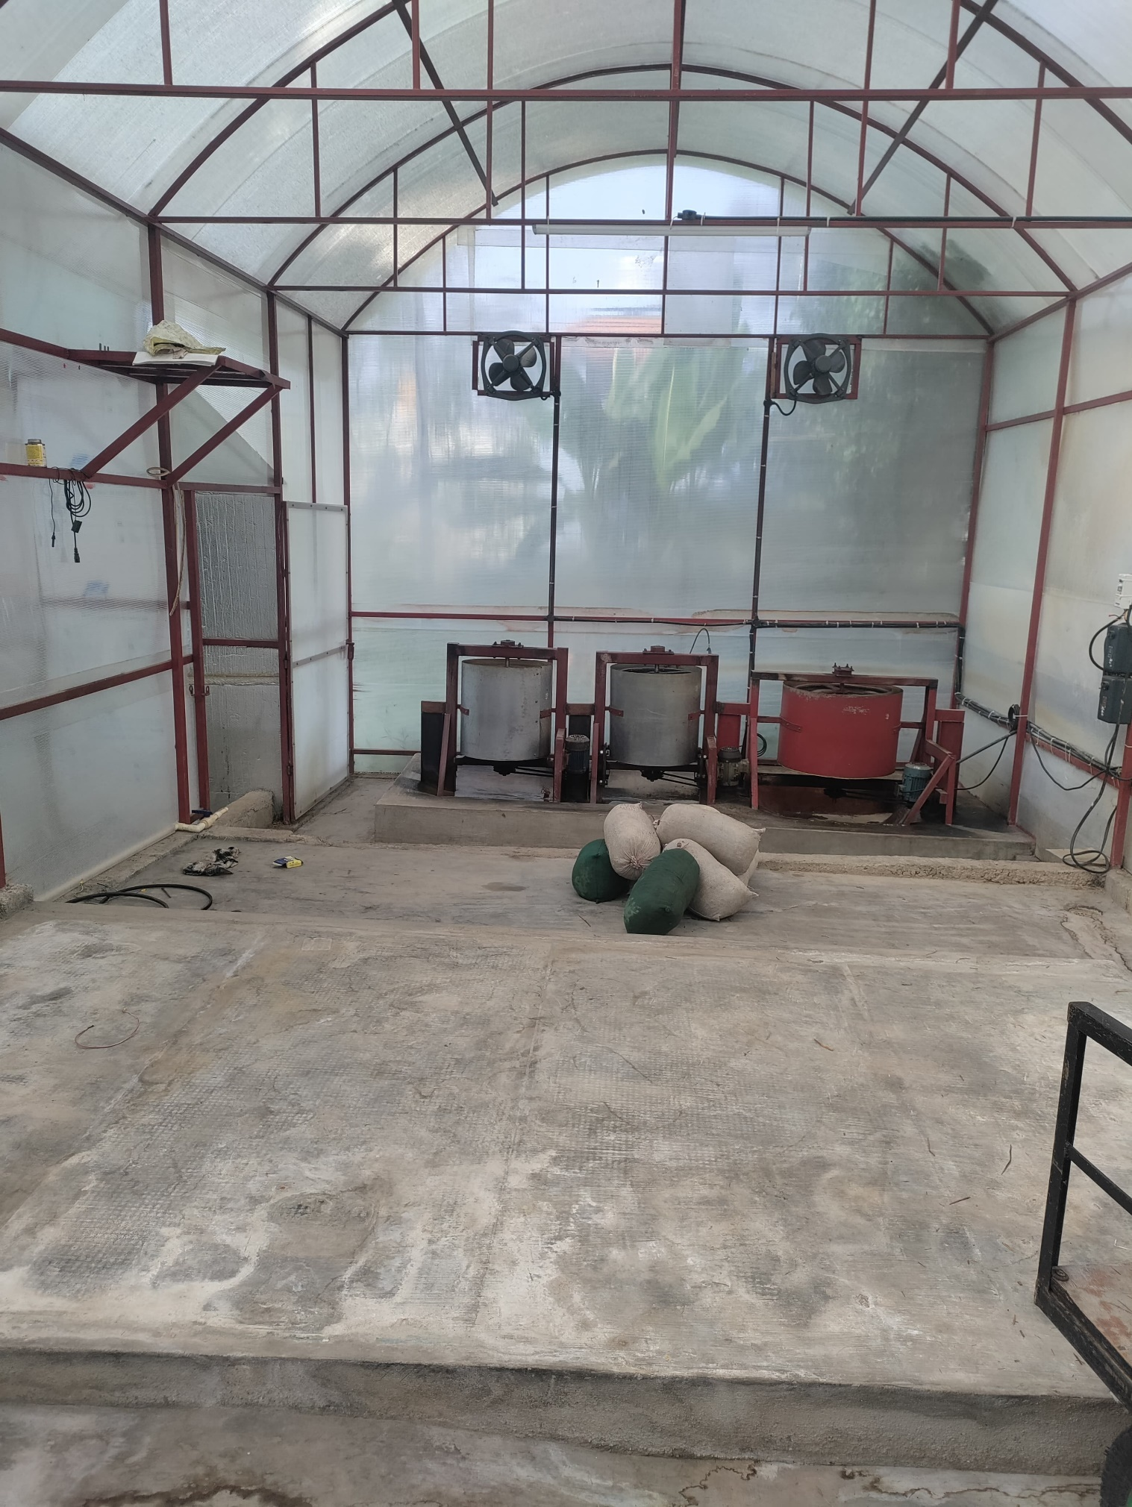

**CHAPTER 5**

**KNOWLEDGE ACQUIRED DURING PYTHON PROGRAMMING**

**1. Python Basics:**

**High-Level Programming Language:** Python is a high-level language, meaning it's closer to human language than machine code. This makes it easier to learn and use compared to lower-level languages.

**Interpreted vs. Compiled:** Python is an interpreted language, meaning the code is executed line by line at runtime, unlike compiled languages that generate machine code beforehand.

**General-Purpose:** Python is a general-purpose language, meaning it can be used for various tasks like web development, data analysis, machine learning, scripting, and more.

**2. Python Syntax and Data Structures:**

**Easy-to-Read Syntax:** Python is known for its clear and concise syntax, with a focus on readability. Indentation plays a crucial role in defining code blocks.

**Data Types:** You likely learned about various data types in Python, including integers, floats, strings, booleans, lists, tuples, dictionaries, and sets. Each has its specific use case.

**Control Flow:** You likely used control flow statements like if, else, loops ( for, while) to control the flow of your program based on conditions.

**Functions:** Functions allow you to break down complex tasks into smaller, reusable blocks of code, promoting modularity and code organization.

**3. Object-Oriented Programming :**

**Classes and Objects:** Depending on the internship project, you might have learned about Object-Oriented Programming (OOP) concepts like classes, objects, inheritance, polymorphism, and encapsulation.

**Classes define blueprints** for creating objects with attributes (data) and methods (functions) that operate on that data.

**4. Python Libraries and Frameworks:**

**The Rich Ecosystem:** Python boasts a vast ecosystem of libraries and frameworks for various domains. You likely used libraries specific to your project's needs.

**Examples:** Some popular libraries include NumPy (numerical computing), pandas (data analysis), Matplotlib (data visualization), Django/Flask (web development), Scikit-learn (machine learning), Beautiful Soup (web scraping), and many more.

**5. Beyond the Basics:**

**Version Control (Optional):** You might have learned about using version control systems like Git to track code changes and collaborate effectively.

**Testing (Optional):** Depending on the internship's structure, you might have been introduced to writing unit tests to ensure your code functions as expected.

**Problem-Solving with Python:** The core of your internship likely involved applying Python concepts and libraries to solve a specific problem. This honed your problem-solving skills and algorithmic thinking.

**CHAPTER 6**

**OUTCOME FOR PYTHON PROGRAMMING**

**Skills Development:**

* **Understanding of Python Fundamentals:** This includes grasp of syntax, data structures (lists, dictionaries, tuples), control flow (if/else, loops), functions, and object-oriented programming concepts (classes, inheritance, polymorphism) if applicable.
* **Problem-Solving Abilities:** How effectively could you translate problems into Python code? Did you improve your algorithmic thinking and approach problems in a structured way?
* **Experience with Python Libraries:** Did you learn and utilize libraries relevant to your internship project? This could involve data analysis libraries (pandas, NumPy), web development frameworks (Django, Flask), machine learning libraries (Scikit-learn, TensorFlow), or others depending on the project's focus.
* **Coding Practices:** Did you write clean, maintainable, and well-documented code? Did you learn best practices for version control (Git) and testing your code?

**Project Completion:**

* **Functionality:** Did your code achieve the intended goals of the project? Was it functional and produced the desired results?
* **Complexity:** How complex was the project you undertook? Did it involve working with large datasets, complex algorithms, or interacting with external APIs?
* **Problem-solving During Development:** Did you encounter challenges during development? Were you able to troubleshoot issues effectively and find solutions using Python concepts and libraries?

**Overall Growth:**

* **Confidence in Python Programming:** Did your comfort level with Python increase significantly? Are you now more confident in your ability to tackle new Python challenges?
* **Ability to Learn Independently:** Did you demonstrate the ability to learn new concepts and libraries on your own when needed for the project?
* **Interest and Motivation:** Did the internship spark your interest in continuing to learn and explore Python further?

**Career Advancement:**

* **Improved Job Prospects:** Having Python programming skills on your resume significantly increases your marketability for various technology-related jobs.
* **Competitive Advantage:** In fields like data science, web development, and machine learning, strong Python skills are a major advantage. The internship experience gives you a head start.
* **Higher Earning Potential:** Python skills are in high demand, and professionals with these skills often command higher salaries.
* **Career Path Specialization:** Your internship might have exposed you to a specific area of Python application (data analysis, web scraping etc.). This can help you decide on a specialized career path within the tech industry.

**Personal Growth:**

* **Problem-Solving Skills:** The internship likely involved tackling real-world problems using Python. This experience hones your problem-solving skills and ability to think critically.
* **Self-Motivation and Discipline:** Completing an online internship requires self-motivation and time management skills to learn independently and meet deadlines.
* **Communication Skills (Optional):** Depending on the internship structure, you might have had opportunities to communicate project progress or challenges. This can improve your technical communication skills.
* **Increased Interest in Programming:** A successful internship can solidify your interest in programming with Python, motivating you to continue learning and exploring new possibilities.

**CHAPTER 7**

**CONCLUSION FOR ENTREPRENEURSHIP**

In conclusion, the journey of digitalization within the mushroom cultivation business has yielded transformative outcomes, revolutionizing operations, enhancing decision-making capabilities, and driving sustainable growth. Through the implementation of digital tools and technologies, the business has achieved streamlined operations, increased efficiency, and improved product quality and consistency. Furthermore, digitalization has facilitated expanded market reach, enhanced customer engagement, and optimized resource utilization, leading to cost savings and improved profitability.

The success of digitalization initiatives underscores the importance of embracing innovation and leveraging technology to adapt to evolving market dynamics and customer preferences. Moving forward, the business is well-positioned to capitalize on emerging opportunities, drive continuous improvement, and maintain its competitive edge in the mushroom cultivation industry.

As the business continues its digital transformation journey, it remains committed to fostering a culture of innovation, collaboration, and sustainability. By staying agile, responsive, and forward-thinking, the business will continue to thrive in a rapidly evolving landscape, delivering value to customers, stakeholders, and the broader community.

In essence, digitalization has not only revolutionized the way the mushroom cultivation business operates but has also laid the foundation for future success and resilience in an increasingly digital-driven world. By embracing digital transformation as a strategic imperative, the business is poised to achieve sustainable growth and make a positive impact on the industry for years to come.

**CONCLUSION FOR PYTHON PROGRAMMING**

In conclusion, my Python programming internship has been a valuable learning experience. Through this internship, I have gained a strong foundation in Python syntax, data structures, and libraries. I am now confident in my ability to [mention specific skills you developed, e.g., write clean and maintainable Python code, solve problems algorithmically, work with data using Python libraries]. I am grateful for the opportunity to have participated in this internship and I look forward to applying my newly acquired skills to future endeavors.

**REFERENCES**

[**https://www.w3schools.com/python/**](https://www.w3schools.com/python/)

[**https://chatgpt.com/?oai-dm=1**](https://chatgpt.com/?oai-dm=1)

[**https://gemini.google.com/app**](https://gemini.google.com/app)

[**https://www.udemy.com/**](https://www.udemy.com/)